**ID:** MandatoryRequirement2

**Description:** Add a line chart and scatterplot in reporting options

**Origin:** Yusi Xu, Claire Robichon

**Supporting example:**

When we load the file for the Presentations and click on the member name, for example “Arntfield, Robert” here, we choose the graph type “Line Chart” and it will show like following.

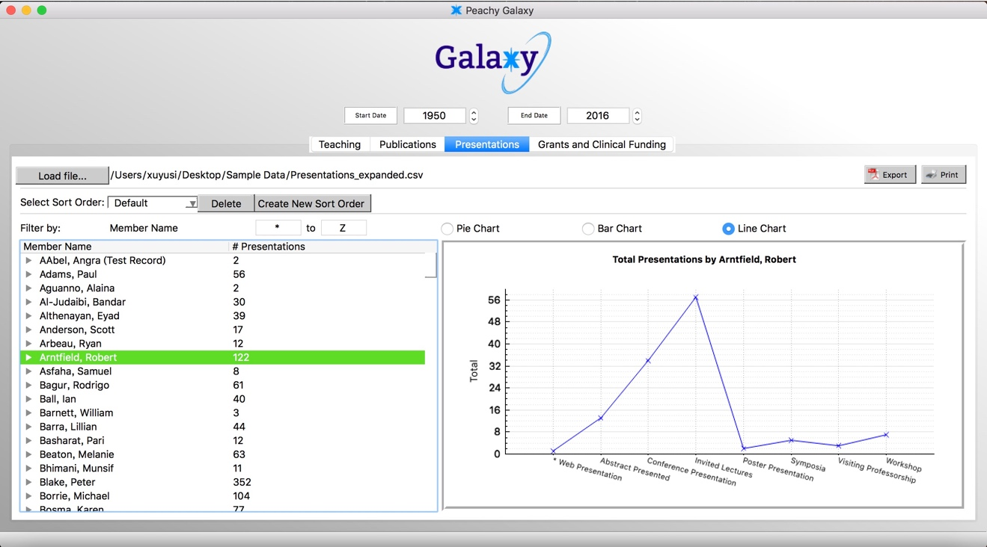

**ID:** MandatoryRequirement9

**Description:** Navigation of Erroneous Entries (Mandatory Requirement)

When the CSV file is loaded for the first time, the error dialog box should report total number of errors and "Find Next/Prev" button which jumps on to the next/prev error. As the errors are fixed, the error count should go down. After all the errors are fixed, "Find Next/Prev" should be disabled.

**Origin:** Code created by Anthony Giugno

**Supporting Example:** An additional feature for user experiences purposes is also shown in the image below, which is the background color for the error cells turning to green when a specific error has been fixed.

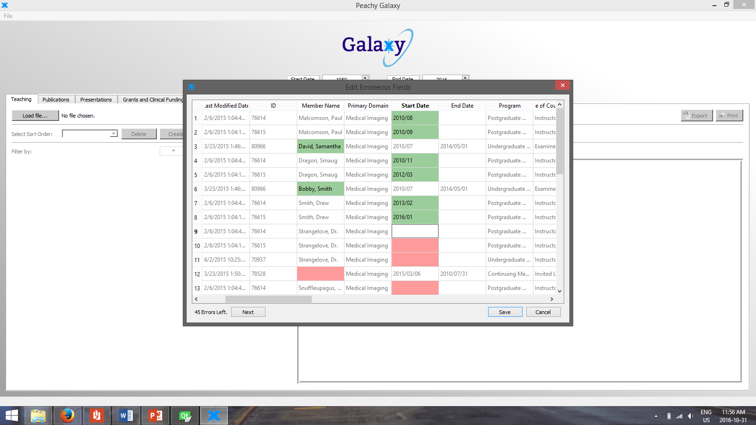

**ID:** MandatoryRequirement3

**Description:** Ability to save session state (Mandatory Requirement)

When the user closes and reopens the application, all the data that was loaded into the program will be saved and re-opened again. The user does not have to re-upload the data.

**Origin:** Code created by Haitian Yu, Anthony Giugno, Claire Robichon

Supporting Example:

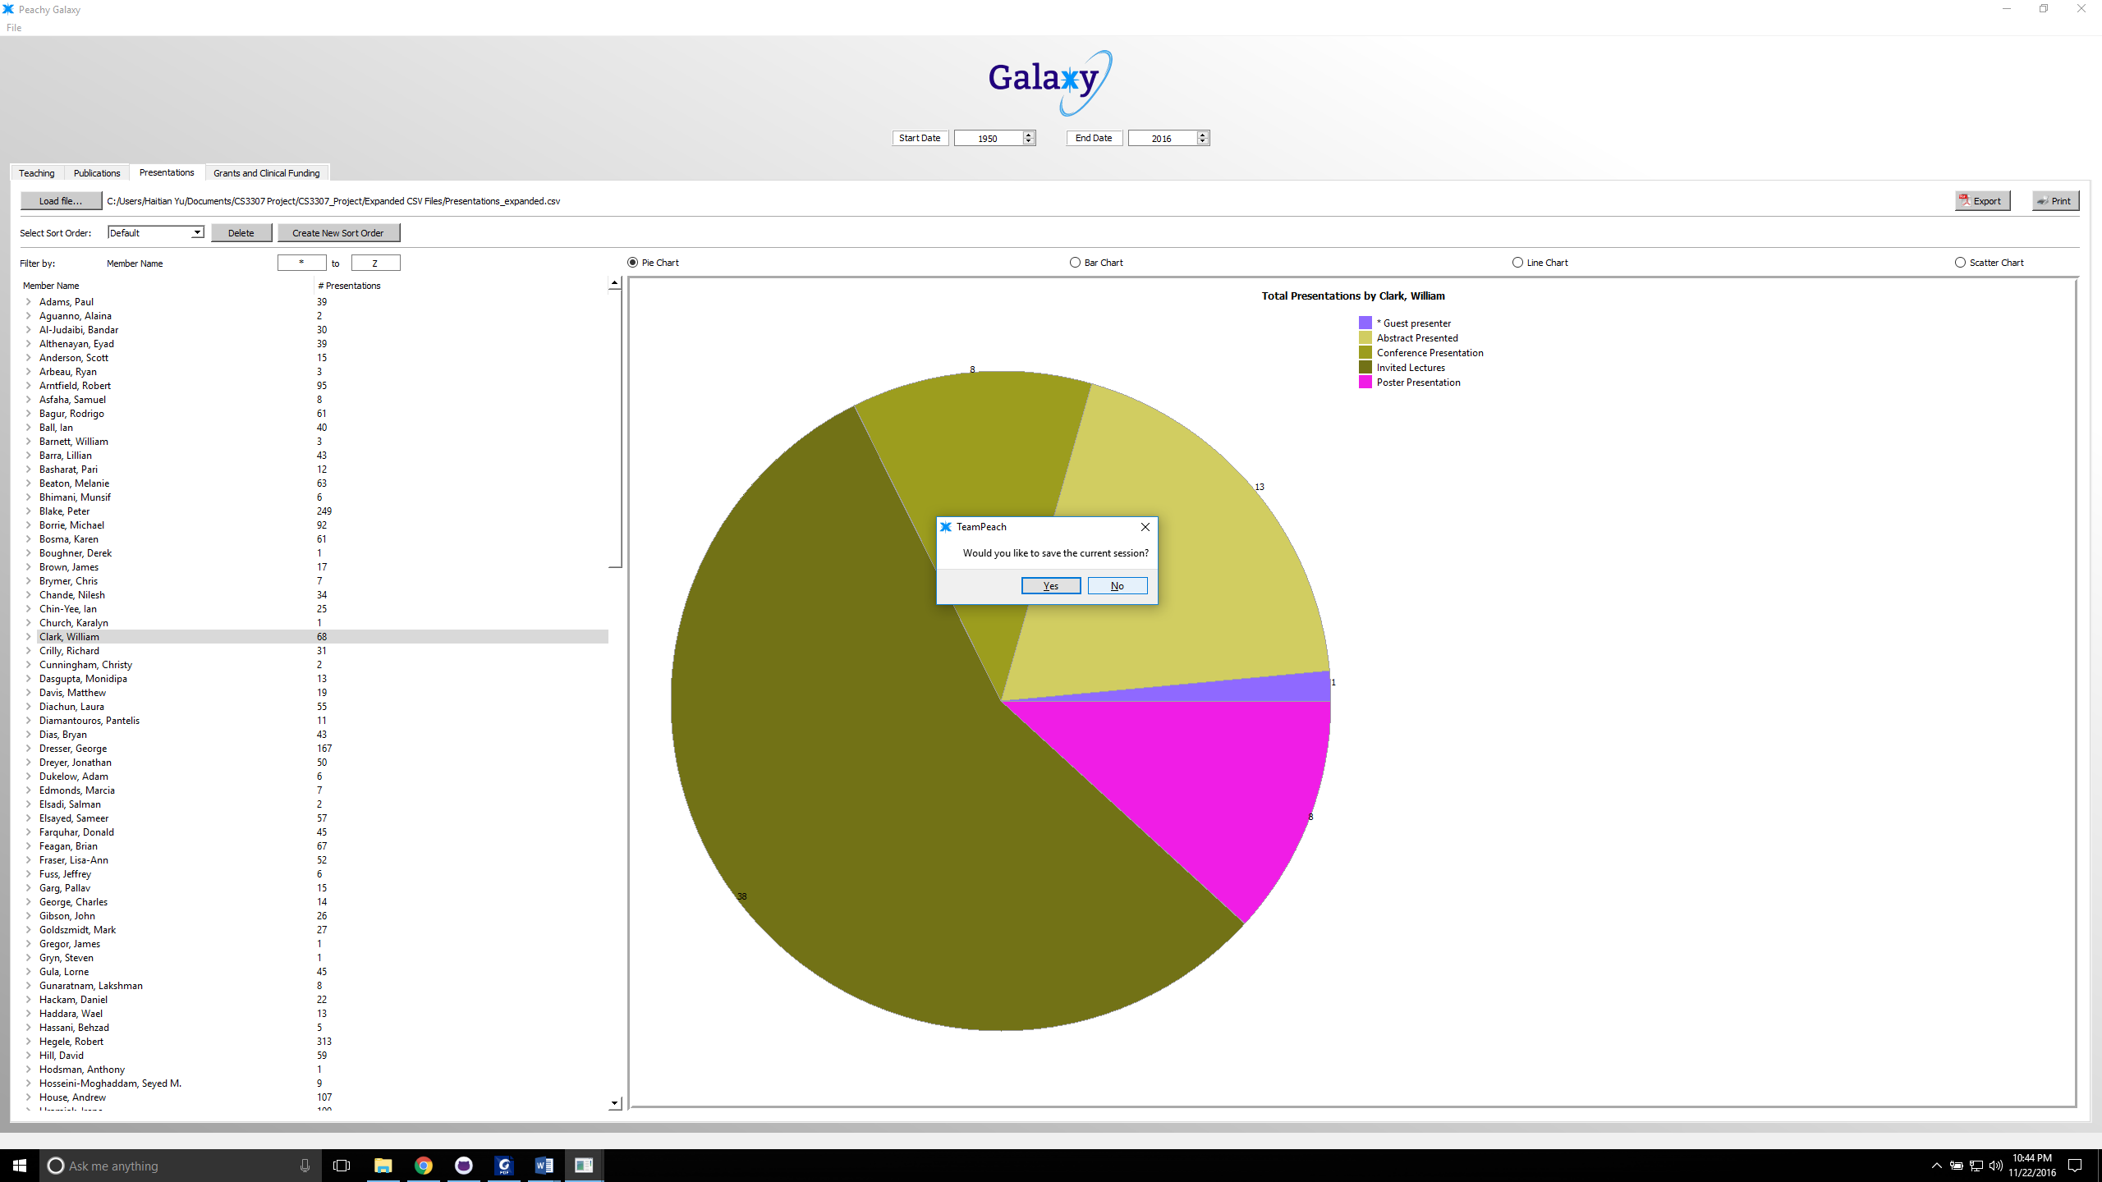

**ID:** MandatoryRequirement4

**Description:** Adding the ability to sort by the member’s division

Before, in the drop down menu, there was only the option to select sort order. We have added the option to sort by member’s division.

**Origin:** Code created by Aboudi

**Supporting Example**: **INCOMPLETE**

**ID:** MandatoryRequirement5

**Description:** Adding the ability to sort by a user selected list

Before, there was no option to sort by options other than member name, type, status date, role, or title. This will add the option to sort by anything the user wants.

**Origin:** Code created by Aboudi

**Supporting Example:** **INCOMEPLETE**

**ID**: MandatoryRequirement6

**Description:** Fix all errors so finished product is error free

**Origin**: Coded by all members of the team

**Supporting Example**: **INCOMPLETE**

**ID:** MandatoryRequirement7

**Description:** Create a userproof install file that includes the executable file, supporting documentation, and all supporting files

**Origin:** Created by Anthony Giugno, Haitian Yu, and Claire Robichon

**Supporting Example:**

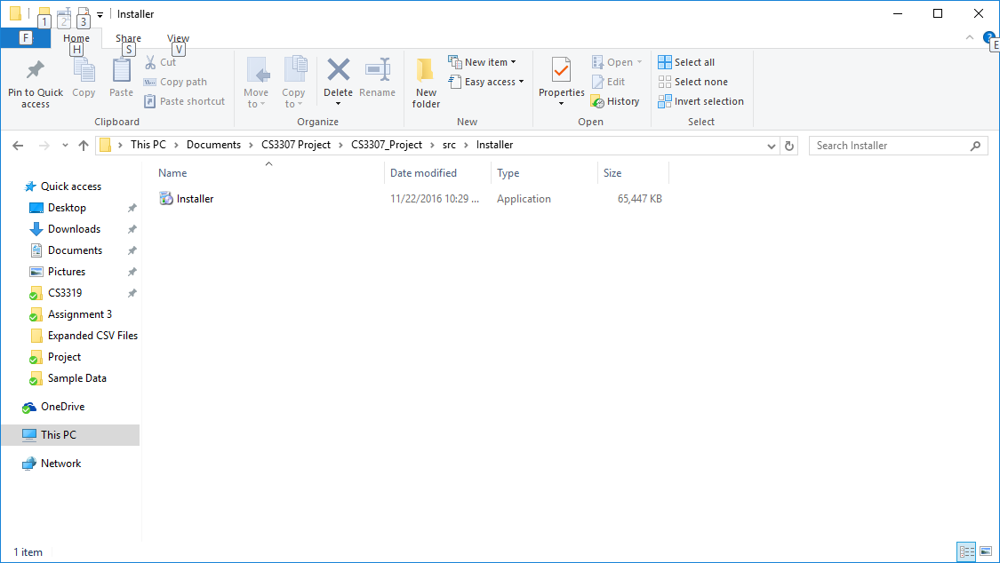

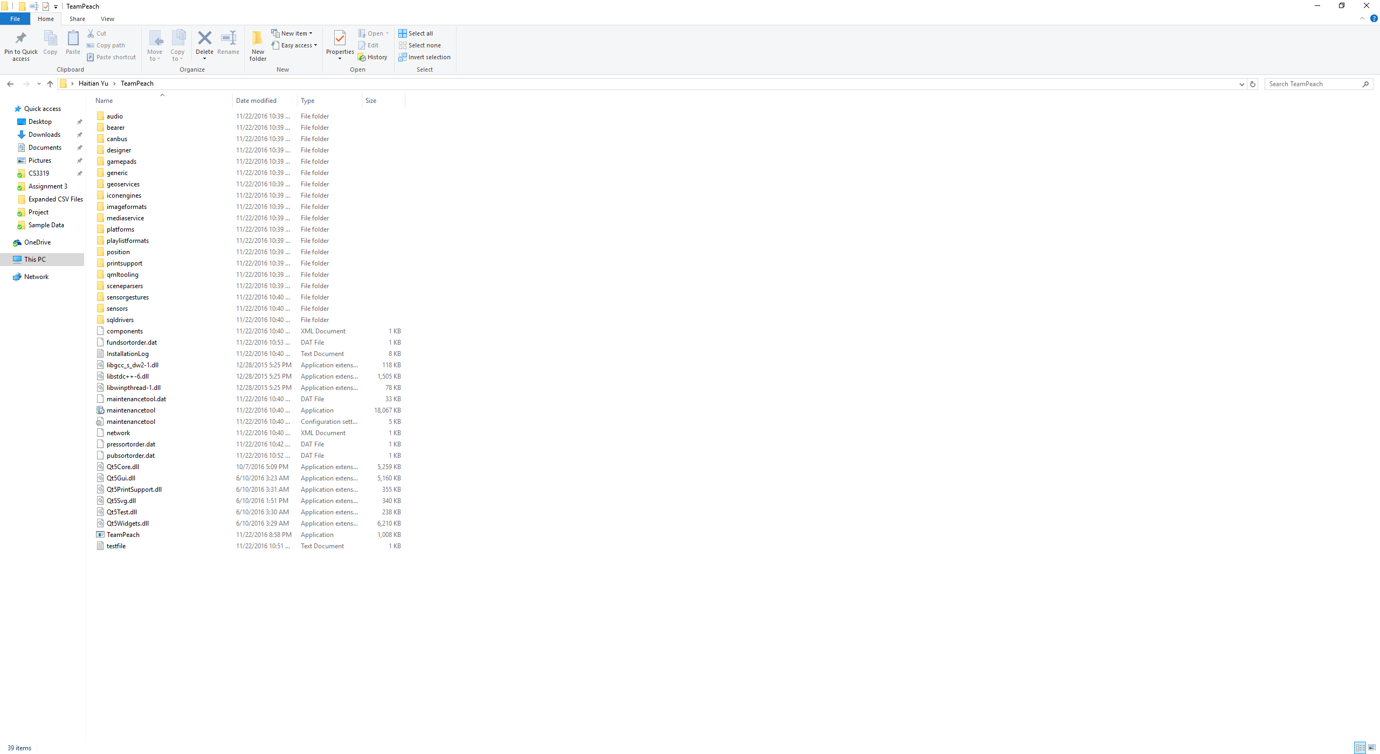

**ID:** MandatoryRequirement8

**Description**: verify the code deck for operation on Windows 7 or Windows 10

**Origin**: Created by Anthony Giugno, Haitian Yu, and Claire Robichon

**Supporting Example**:

The following print screen shows the application working on a Windows 10 operating system. It also works on the windows 7 operating system as well.

